COMANDOS DIGITADOS(GIT) UC11 – ARTHUR GUIMARÃES DE OLIVEIRA  
  
Comandos de Configuração :   
git config --global user.name "Arthur"

git config --global user.email "arthurguimaraes143@gmail.com"

Comandos de Versionamento GIT

git init

git add .

git commit -m "Projeto inicial"

git remote add origin https://github.com/ArthurGuimara/LeiloesTDS

git branch -M main

git push -u origin main

git pull origin main

CAPTURAS DE TELA DO REPOSITÓRIO REMOTO (PRINTS)

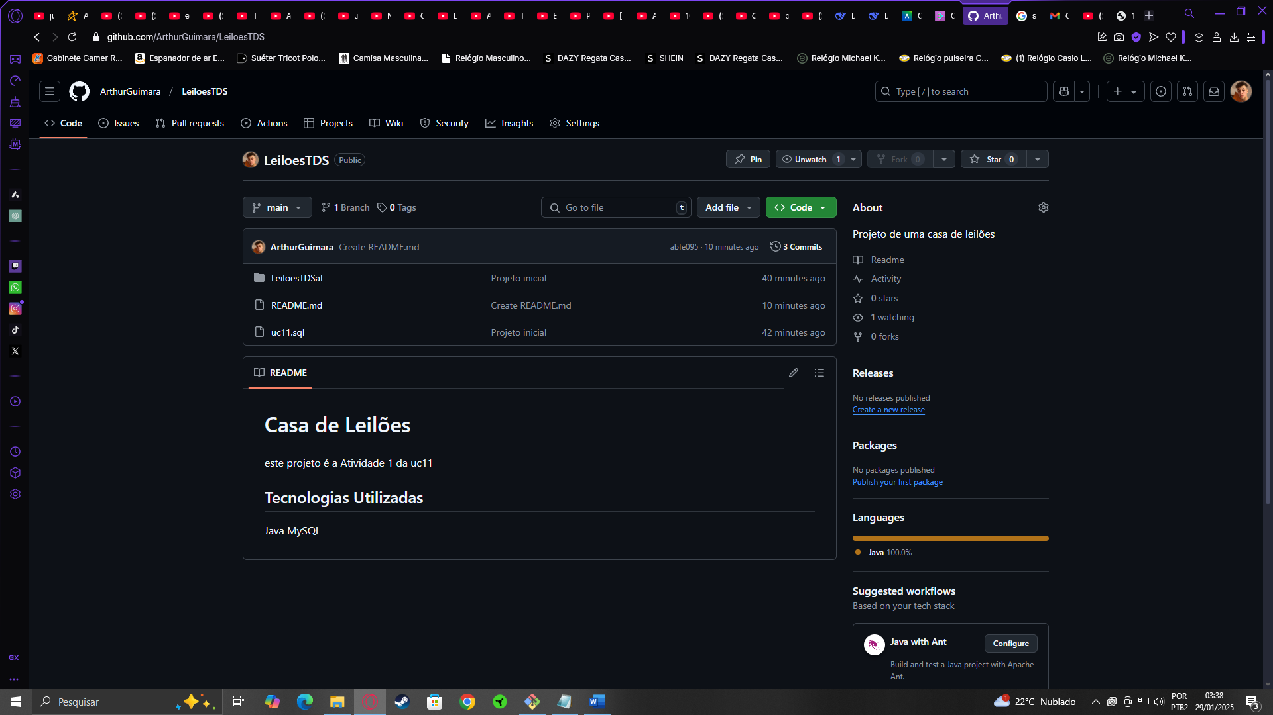

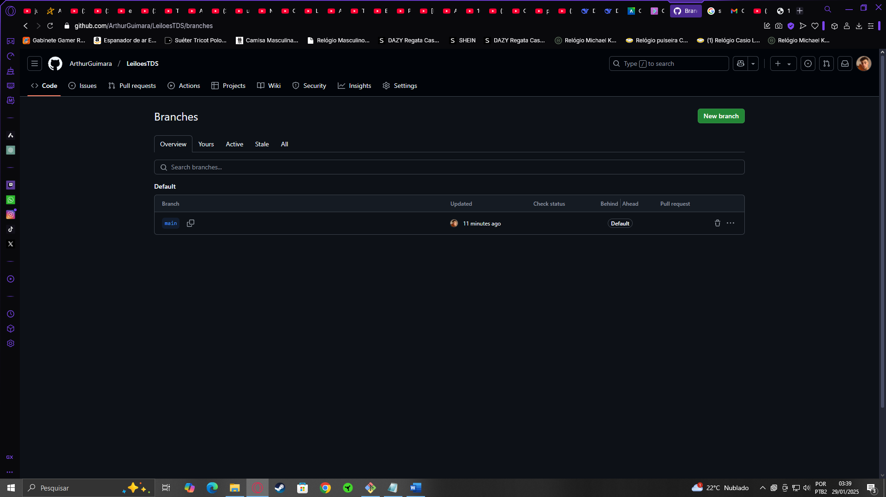

LINK DO GITHUB

https://github.com/ArthurGuimara/LeiloesTDS